**PREDICTING THE SCORE OF WOMEN INTERNATIONAL FOOTBALL GAME**

[HamoyeHQ](https://hamoyehq.medium.com/?source=post_page-----d8edecb6047d--------------------------------)

**HDSC Summer ’23 Capstone Project By**

**Team Matplotlib**

Since Much attention is not given to female football, we team Matplotlib are working on a dataset to predict the score of a women international football game and identifies hidden truth on the dataset to develop strategies to add more fun to women game so that it will attract much attention worldwide as their male counterpart do.

The dataset includes **4884** women's international football results. All are result of major tournament. Some international friendlies, particularly tournaments are also in the dataset. The dataset comprises of 4884 records and 9 fields.

**Aim and Objectives**

The goal of this project is to deploy a machine learning model that predicts the score of women football games with the dataset provided.

**Flow Process**

The steps taken are illustrated with the ﬂowchart below:

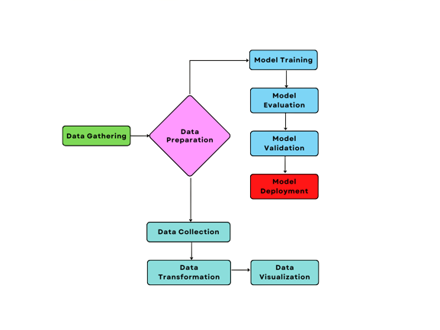

**Data Gathering**

The dataset was obtained from Kaggle via the link below: [https://www.kaggle.com/datasets/martj42/womens-international-football-results]

**Data Preparation**

The following procedures were used to prepare the data:

* Data collection: The dataset was relational and structured dataset, and it consisted of 4884 rows and 9 columns. The name of the columns are as follows:
* Date
* Home_team
* Away_team
* Home_score
* Away score
* Tournament
* City
* Country
* Neutral

# Data Cleaning: The dataset is consistent, since it did not have null and duplicate values. The only issue is to change the columns to their appropriate datatype.

**Converting data type of each column to it appropriate data type.**

|  |  |  |  |
| --- | --- | --- | --- |
| S/N | Column Name | Default Datatype | Appropriate/change datatype |
| 1 | Date | Object | Date-time |
| 2 | Home_team | Object | String |
| 3 | Away_team | Object | string |
| 4 | Home_score | Object | Int |
| 5 | Away_score | Object | Int |
| 6 | Tournament | Object | string |
| 7 | City | Object | string |
| 8 | Country | Object | String |
| 9 | Neutral | Boolean | Boolean |